Boat checks to be done before every outing. If you are not sure, ask your coach or view this YouTube video https://www.youtube.com/watch?v=Jv294UHbj0s | 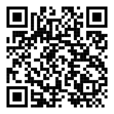 | 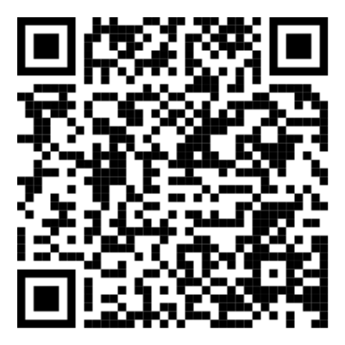  QR Code for Equipment Fault Report
You can also read RowSafe chapter 7. https://www.britishrowing.org/wp-content/uploads/2023/04/2023-British-Rowing-RowSafe.pdf | 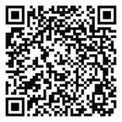

Boat Checks to be done before every outing. Take a photo to remind you.

Where to check | What to check | Tick if OK | Cross if Not OK – what have you done about it?
Boat Hull | No Holes
 | No Scratches
 | No damage to canvas on top of boat
Rudder and lines (if fitted) | Check rudder strings are moving freely
 | Rudder Moves freely and operates correctly with lines
Finn | Fixed and straight
Riggers | Swivels move freely
 | Gate opens and closes securely
 | Check gate top nuts and backstay fixings
 | Rigger fixings to boat are firm and secure.
Bow Ball | Ball not damaged
 | Bow ball securely fixed
 | Bow ball vent closed if present
Feet stretchers | Firmly fixed to boat, locking nuts tightly secured.
 | Check stretcher tracks fixings
Shoes | Pulling Velcro quick release with one hand opens both shoes
 | Shoes are securely fixed to the stretcher under the toes
 | Shoes are in good condition
Heel restraints | Should prevent the heel raising above horizontal
 | Should be strong and durable. NOT laces or cable ties.
Seats and runners | Seats run freely
 | Runners should be clean, stable and set evenly
Hatch covers | Open, check they are attached to boat with a string and then close securely.
Blades | No damage, buttons secure and properly set (ie matching position for sculling blades)

